Analytic Edge Pvt Ltd

Modeling Methodology  
Bolt

Version 1.0

**Table of Contents**

1. Background 2

2. Demand Drivers Edge (DDE) Modeling Module 2

2.1. Model Scope 2

**2.1.1.** **Additive** 2

Volume=Intercept+β1* Precipitation+β2* Media+β3* Promo+.... 2

**2.1.1.1** **Multiplicative:** 3

Volume=Intercept⋅ e^(β1* Precipitation )⋅e^(β2* Media )⋅e^(β3* Promo)⋅... 3

3. Model Specifications - 3

**3.2** **Model Measures** 3

**3.3.** **Measure Transformations – (NRC)-to be updated** 4

4. Model Quality Criteria 5

5. Model treatment – (specific to Bolt’s marketing variables) 5

4. MMx Reports 8

4.1. Volume Contribution 8

4.2. Due-To Change YOY (NRC) 8

4.3. Cost of Acquisition 9

**2.1.1.2** **Pooled Model** 10

**2.1.1.3** **Bayesian Shrinkage** 10

**2.1.1.3.1** **Bayesian Priors** 12

**2.1.1.3.2** **Estimation** 12

4.4. Synergy 13

4.5. Face Validity 1: Data transformations based on mental models and adhering to global best practices 14

4.6. Face Validity 2: Correct signs on coefficients 14

4.7. Face Validity 3: Elasticities or volume response rates within reasonable ranges 15

4.8. Face Validity 4: Interactions and competitive effects within reasonable ranges 15

4.9. Face Validity 5: Volume contributions within reasonable ranges 15

4.10. Face Validity 6: Change to year ago due to errors of reasonable size 15

4.11. Face Validity 7: Change to year ago due to effect sizes sensible 15

4.12. Face Validity 8: Minimum use of dummy variables 15

4.13. Statistical Validity 1, 2: MAPE’s and R2’s 15

4.14. Statistical Validity 3: Small Correction Factor 16

4.15. Statistical Validity 4: Actual, Predicted, Error Time Series 16

4.16. Statistical Validity 5: Coefficient Confidence 17

4.17. Statistical Validity 6: Forecasting Accuracy 18

# Background

MMx analysis is an analytical solution that estimates sales (Units, Volume, Revenues, Shipments) as a function of marketing activity and other measures describing the state of the market.

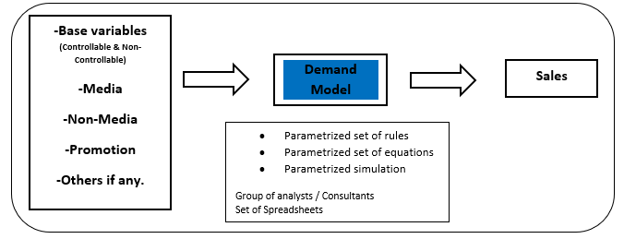

MMx analysis is used for:

* Measuring the contribution of activities to sales; disentangling the effects that are happening simultaneously.
  + Volume contribution from activity; translates into ROI.
  + Explain volume differences over time.
* Enhancing understanding of the marketplace
  + Measuring the impact of an activity; Price elasticity, promotion lift and strength of competitor’s impact.
* Predicting sales for any marketing plan
  + Media budget simulation and optimization
  + Sales forecasting
* Monitoring of changes in the marketplace
  + Does my old model still comply with the current data?
  + How do models calibrated on old and new data differ?
  + What does it say about the effectiveness of activities?

# Demand Drivers Edge (DDE) Modeling Module

# Model Scope

We develop MMx models using our platform Demand Drivers *Edge* (DDE). DDE runs statistical models by blending POS, media, promotions, macro-economic indicators data and any other client specific inputs required to quantify the relationship on sales. The DDE supports the following model forms:

* + 1. **Additive:**

Volume=Intercept+β1* Precipitation+β2* Media+β3* Promo+....

**Pros:**

* Easy to estimate
* Easy to analyze / decompose

**Cons:**

* Requires careful normalization
* Does not capture changes in baseline measures well
* Has a relatively small validity range

### **Multiplicative:**

Volume=Intercept⋅ e^(β1* Precipitation )⋅e^(β2* Media )⋅e^(β3* Promo)⋅...

**Pros:**

* Larger relevant range
* Implicitly captures some interactions.

**Cons:**

* May create some counter-intuitive interactions that may not meet face validity.

**Choice of the model form depends on:**

* Mental model of how activities affect volume in the specific business.
* Nature of business questions to be supported.
* Data availability
* Estimation technique to be employed.

# Model Specifications -

* 1. **Model Measures**

Typically, measures to be modeled can be grouped into the following categories:

* **Base**
* **Macro Environment**
  + Temperature
  + Precipitation
* **Calendar**
  + Weekend Flag
  + Holiday
* **Price**
  + Avg Distance Price
  + Avg Supply Demand Multiplier
* **Others**
  + Bolt ETA
  + Mobility Data
* **Media**
  + Facebook Impressions
  + Google Impressions
  + Apple search Impressions
  + OOH Impressions
  + Twitter Impressions
  + Snap Impressions
  + Tik-Tok Impressions
  + Influencer’s & Blog visitors’ data
* **Non-Media**
  + Signup’s cost
  + Event Cost
  + Referral cost
  + Lifecycle data
  1. **Measure Transformations**

Analytic Edge MMx platform has many transformations built-in that are documented in the marketing science literature and widely used across clients. Following are a few in-built transformations in DDE:

1. **Direct** – “Direct” indicates the measure will be used as is in the model without any transformation.
2. **Log** – “Log” indicates the natural log of the measure will be used in the model. Taking logarithm of a variable implies that effects dampen at higher levels.
3. **Lag** – “Lag” indicates the lagged values of the measure will be used in the model. If the time is in weeks, user has to provide the number of weeks by which the measure will be lagged.



1. **Moving Average** – It indicates moving average values of the measure will be used in the model. It takes one input parameter i.e. Period and the value should be greater than 0.
2. **Ad-Stock** – Ad-Stock takes one input parameter called Decay. Decay parameter value of 0.1 means 90% of the impact of advertisement is observed during the time of execution and remaining 10% of the impact of advertisement is carried forward to remaining periods.

Decay parameter takes values between 0 and 1 and the standard values used are 0.1, 0.2, ---- 0.9.

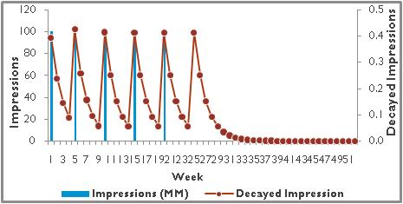

1. **Exponential** – Exponential takes two input parameters viz. # of periods and Decay.

# of Periods takes any discrete value greater than 0. It specifies the number of periods taken for the effect of the advertisement to exponentially decay.

Decay parameter value of 0.1 means 90% of the impact of advertisement is observed during the time of execution and remaining 10% of the impact of advertisement is carried forward to remaining weeks (Will be calculated till the number of weeks specified in the input parameter **Weeks**)

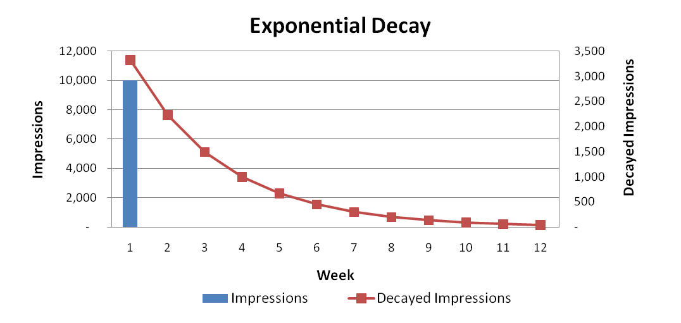

1. **Gamma** – It assumes that viewers who are exposed to media activity react after some time and then declines exponentially within a specific period.

Ad-Bank takes three input parameters viz. Degrees of Freedom, Periods and Decay.

**Degrees of Freedom** – The minimum time (# of weeks) required for the advertisement to run and impact the viewers to make purchase decision.

**Periods** - It specifies the number of periods the impact of advertisement may last.

**Decay parameter** The decay effect of current period activity that is carried forward.

# 

# Model Quality Criteria

Model quality criteria can be thought of in two broad buckets: statistical validity, and face validity.

**Face validity criteria are:**

1. Data transformations based on mental models and adhering to global best practices
2. Correct signs on coefficients
3. Volume contributions within reasonable ranges
4. Change to year ago due to errors of reasonable size
5. Change to year ago due to effect sizes sensible
6. Minimal use of dummy variables and trend terms

**Statistical validity criteria are:**

1. Low MAPES
2. High R2
3. Small Correction Factor
4. High confidence in coefficients either via reliance on Priors or via high t-stats
5. Forecast accuracy – Holdout MAPE.

The statistical criteria are necessary, but not sufficient for model quality. When not all criteria can be met, face validity is valued over statistical validity.

# Model treatment – (specific to Bolt’s marketing variables)

* 1. **Base –** 
     1. All Variables apart form Marketing and promotion would be part of Base variables. These are **controllable**, usually continuous and can directly or indirectly impact the Bolt business / KPI
     2. It also includes factors that are **uncontrollable** but would still affect the business/ KPI due to the nature of its relationship.

Below is the list of base variables used in the model:

|  |  |  |  |
| --- | --- | --- | --- |
| **Variables** | **Controllable/Non-controllable** | **Transformation used** | **Reasons** |
| Temperature | Uncontrollable | Direct | Immediate effect |
| Precipitation | Uncontrollable | Direct | Immediate effect |
| Bolt ETA | Controllable | Direct | Immediate effect |
| Avg Distance Price | Controllable | Log | Symmetrizes the data |
| Holiday | Uncontrollable | Direct | Immediate effect |
| Lockdown Status | Uncontrollable | Direct | Immediate effect |
| Mobility | Uncontrollable | Direct | Immediate effect |
| Weekend Flag | Uncontrollable | Direct | Immediate effect |

* 1. **Media --**
     1. To test media, we started with some of the most important media variables. Either use business logic or look at the spend share of media variables to identify the biggest ones
     2. Transformation parameters are determined by running multiple iterations and comparing model fits for each.

Below is the list of media variables used in the model.

|  |  |  |
| --- | --- | --- |
| **Metric (Impressions)** | **Transformation used** | **Granularity** |
| Facebook | Ad stock/Gamma | Used by Objective |
| Google | Ad stock/Gamma | Used by Objective |
| OOH | Ad stock/Gamma |  |
| Twitter | Ad stock/Gamma |  |
| Snap | Ad stock/Gamma |  |
| Tik-Tok | Ad stock/Gamma |  |
| Apple | Ad stock/Gamma | Used by Objective |
| Influencers’ reach | Ad stock/Gamma |  |

* + 1. **Use the base model and start by inserting one media at a time.**

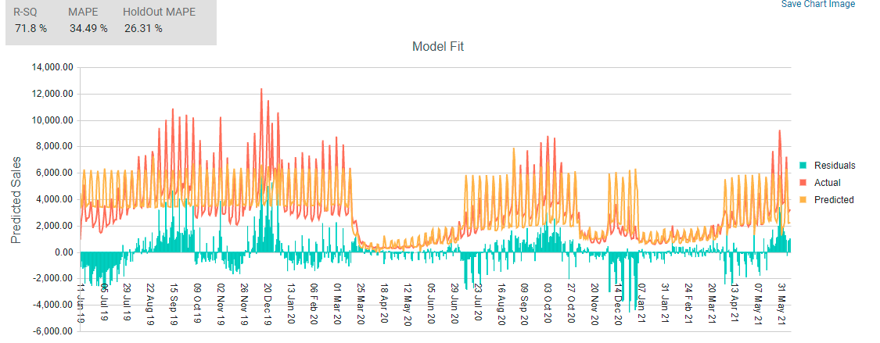

**Mape & R2 before adding the Media Variables.**

**Mape & R2 after adding FB Ads and OOH Impressions**

* + 1. The validation checks we have done after adding a variable.
       1. R square – Does the R square increase after you input this variable in the model.
       2. MAPE / Hold out MAPE – Does the MAPE reduce by inserting this variable.
       3. Coefficient Sign – The sign is indicative of the relationship with the KPI. Media execution should have a positive effect on your KPI so the coefficient should be positive.
       4. VIF – VIF must be low to ensure there isn’t Multicollinearity with any other independent variable.
       5. P value –To Check for significance of the variable &

T stat – alternatively we can also check for T stat for the significance.

* + 1. Keep a track of the above metrics after each iteration.
    2. For each media, multiple iterations can be run and check how are the metrics are varying.





The coefficient that we get after multiple iterations.

* + 1. This will give a range on how media changes based on other variables.
    2. An average of these coefficients can be used a Prior and the range noticed can be the std deviation to be used for the respective variables.

For Eg:

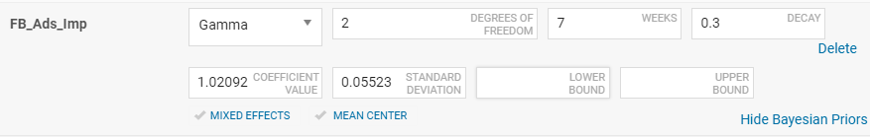

Setting up the coefficient and providing Prior’s (any SD between 10% to 50%)

* 1. **Promotion --**
     1. Sign up cost & Event Cost
        1. The variable can be tested after related media variables are in the model.
        2. Following methods can be used to test this variable in the model.
           1. Using direct cost variable in model – Using cost directly in the model would be good for Model fit and MAPE but may not be accounting for the consumer behavior surrounding this variable.
           2. Splitting variable into ranges by calculating per user cost

Per user cost is calculated by dividing the cost by First time activations

Creating ranged variables based on per user cost eg: 0-5gbp, 5-10 gbp, 10-15 gbp etc. Take a proportion of these variables and use the one that has significant value & Whichever is insignificant in the model can be ignored or added to the base.

This would result in reducing the high correlation that direct cost has with the KPI.

Applying a transformation would also help in capturing consumer behavior associated with this variable.

Transformation can be Moving average of x number of days.

Number of days can be iterative based on how well it spreads the data whist retaining the variation.

* + - * 1. Using Flag variables

Creating a flag variable is a good way to test promotion since it tests for on vs off and eliminates the high correlation of cost with dependent.

Cannot use flag directly with this variable since its continuous

Can use flag after creating the Ranges for per user cost.

Downsides of using flag variable:

If the data for any range is continuous for a long period of time, model would not be able to attribute the right impact from it.

Since data is only on vs off, the day-to-day variation in consumers using this promotion can get diminished.

* + 1. Referral cost
       1. Following methods can be used to test this variable in the model.
          1. Testing cost directly based on Referral value eg: 8gp referral, 10gbp referral etc

Can apply transformations to align it with consumer behavior- Moving average of x days.

* + - * 1. Instead of using cost directly in these variables, use the per user value – Cost / Fist time activations – This will reduce the correlation that direct cost has with KPI.

Can apply transformations to further align it with consumer behavior.

* + - * 1. Using flag variables
  1. **Non-media --**
     1. Lifecycle –
        1. We have tested in the model by breaking the variables by message type.
        2. Can apply Lag transformation to the variables where Lag value is iterative.
           1. Lag transformation will consider the lag it takes for a user to activate after receiving the message.

# MMx Reports

## Volume Contribution

This report decomposes total sales into baseline and incremental considering all measures from the final model. This is one of the key reports in a MMx analysis i.e. decompose total sales into base and incremental.

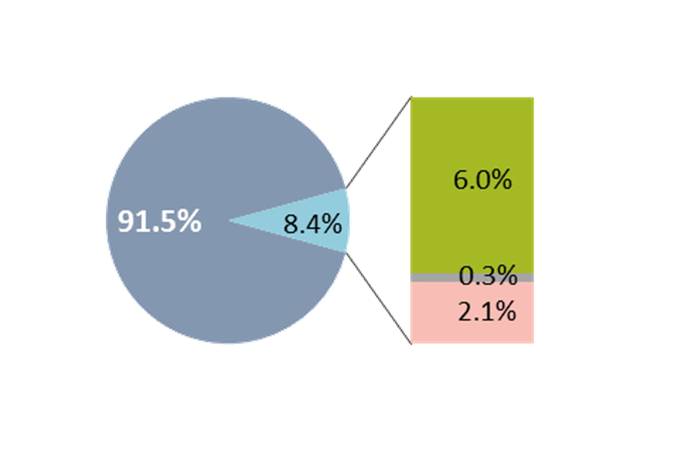

## Due-To Change

Due-to change (%) indicates the change between any two periods in KPI and model breaks down the change and attributes to key drivers in the model.

* In many cases, there is a gap between actual change and model predicted change and this is grouped under the bucket “Others” (Model Error).
* Model error to be kept as low as possible.

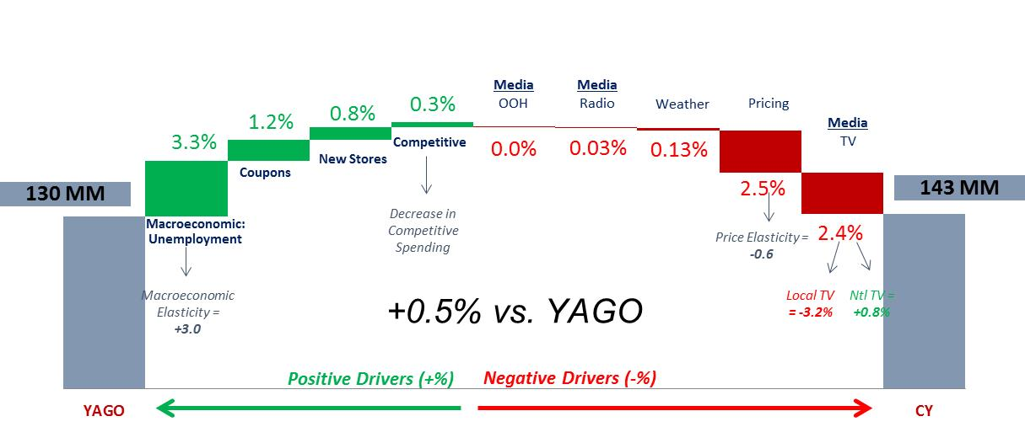

## Cost of Acquisition

Cost of acquisition is calculated as Spends (for respective media) divided by Number of first-time activations.

**Appendix**

### **Pooled Model**

Typically, time-series regression models need a sufficient history of data to yield robust results (you need at least 2 years of data to get sensible results). If you have less than 2 years of data, but you have this for multiple groups, like channels, PPG’s, then you can still build a "pooled" model by combining time-series observations across several groups.

If you have sales data for 70 weeks from 10 different markets, you would not be able to build a regular model as you do not have 104 weeks of data, but you would be able to build a Pooled regression model because by pooling data, you have 10 times 70=700 data points instead of 70.

Pooled regression works similar to regular regression, except an extra intercept or ‘dummy’ is added for each cross section. It is important to remember that Pooled Regression Coefficients do not measure demand effect separately for each cross section, but yield an ‘overall’ measure of demand.

In many countries, data is available at a monthly level and may not have a good historical record. In such cases, using data at the dimensional level will help increase the number of data points required to develop a robust model.

### **Bayesian Shrinkage**

DDE allows users to develop Bayesian shrinkage models. Few other names used for Bayesian shrinkage models are mixed effects model, hierarchical regression model, multi-level model and variance components model with random effects. Bayesian shrinkage modeling approach is useful in the following cases:

* There are multiple cross sections and differences across these cross sections
* Relationship in a regression model varies by cross sections
* Practically not feasible to develop hundreds of models in time for business planning

Bayesian shrinkage:

* Fits a regression equation at the cross sectional level
* Allows estimates of the regression equation vary by cross section
* Uses cross sectional level measures to explain variation in the individual-level parameters
* Allows to test for main effects and interactions within and between levels

These models are very strict on the data related assumptions:

* Data needs to be normally distributed
* Means of the data are linear in terms of a certain set of parameters (fixed-effects parameters) -- same as standard linear model
* Variance and covariance of the data are structured and are in terms of a different set of parameters (covariance parameters) -- different from standard linear model
* Random effects parameters are normally distributed. This assumption serves to shrink outlier estimates toward the overall mean

Recent academic work has shown the advantages of using Bayesian Shrinkage Methodology over Market Level Models (Boatwright, McCulloch and Rossi 1999)

Step I - Build a model for each cross section separately using time series cross sectional data (Assume we have markets and channels within markets)

*yij = β*0*j + β*1i *Xij + εij  
…… i = Markets j = Channels*

……………. (1)

**Step II** - Regression Parameters from step1 are then regressed on channel level data describing the markets process

*β*0*j = γ00*  + *γ01* market size +*  u0j

………….. (2)

Substituting (2) in (1), we get

*yij = γ00 + γ01 Xij*  *+u 0j +εij*

Random

Effect

Fixed

Effect

The platform uses “R” statistical software to run Bayesian shrinkage model.

1. **Bayesian Priors**

Often, the dataset at hand contains all the information that is available and needed to create an accurate demand model. Most clients have access to prior information that was distilled from other data sources and should be incorporated into demand models. Bayesian Estimation techniques are the best understood and most consistent tools to incorporate that information.

The platform allows use of Bayesian priors at the measure level to include in the model. Analytic Edge recommends using **weighted priors** derived by weighting past estimates and estimates from new data. These weighted priors must be within the distribution/standard deviation of the fixed effects estimates from the new data.



* **Prior distribution** – probability tendency of an uncertain quantity, β, that expresses previous knowledge of β from, for example, a past experience, with the absence of some proof
* **Posterior distribution** – this distribution takes proof into account and is then the conditional probability of β. The posterior probability is computed from the prior and the likelihood function using Bayes’ theorem.
* **Posterior mean** – the mean of the posterior distribution
* **Posterior variance** – the variance of the posterior distribution
* **Conjugate priors** - a family of prior probability distributions in which the key property is that the posterior probability distribution also belongs to the family of the prior probability distribution

1. **Estimation**

Let *θ* be an unknown parameter based on a random sample, *x1, x2, …, xn* from a distribution with pdf/pmf *f (x | θ).*

*Let π (θ) be the prior distribution of θ.*

*Let π* *(*θ | x1, x2, …, xn*) be the posterior distribution.

**Note that *π* *(*θ | x1, x2, …, xn*) is the condition distribution of *θ* given the observed data, *x1, x2, …, xn*.

If we apply Bayes Theorem (Eq. 15.1), the posterior distribution becomes:

Two most commonly used methods of estimation are **MAP** (Maximum a Posteriori) and **MCMC** (Markov Chain Monte Carlo). MAP is similar to the MLE method of estimation with an addition of the prior term in the likelihood function. Estimation using MAP is difficult as figuring out gradient function for Newton Raphson are not always easy unless the assumption of conjugate priors is true (not always the case).

MCMC estimation works by taking samples from the posterior distribution of the data given the parameters.

Based on the prior information, MCMC finds out the shape of the distribution and outputs it as the parameter value. This brute force approach is useful when a balance is required between statistical and face validity. DDE uses Gibbs sampling algorithm assuming is known.

## Synergy

The platform provides the ability to generate key reports required in any MMx analysis. The platform has the ability to quantify both non log and log models. The platform has built-in additive and subtractive approach to correct for synergy effects introduced because of using a multiplicative model form. For the purpose of , we recommend using a **subtractive approach** to maintain consistency.

**Subtractive approach:**

* Turn all marketing levers off. Volume estimate is base
* Turn marketing levers off, one at a time. Each time, total volume minus simulated volume is incremental volume from that activity

Log(volume) = beta1*covariate1 + beta1 * covariate2 + etc.

Volume = exp(beta1*covariate1) * exp(beta1 * covariate 2) * etc.

Synergy: 43.1 – 46.5 = -3.4 equation then becomes: make the ssures by aggregating any of the existing measures or the tal vel model

## Face Validity 1: Data transformations based on mental models and adhering to global best practices

Mental models and conceptual data transformations are relevant in MMx analysis. For e.g. in a multiplicative model, price has to be a log transformation. All media measures need to have a transformation that follows concepts from marketing literature. For e.g. Ad-Stock function to model media measures.

Adstock helps identify how response to advertising builds and decays over time across geographies where advertisement occurs. Functional form of adstock is:

Ad Stock(TV)t = 1-(1- Ad Stock(TV)t-1 *EXP(-***Decay***))/EXP((TV)t/100\****Learn***)

Where decay is the rate at which awareness declines

Learn is the level post which saturation or diminishing returns occur

Adstock transformation needs 2 parameters; Learn and Decay

Decay parameter takes values between 0 and 1 and the standard values used are 0.1, 0.2, ---- 0.9. Decay parameter value of 0.1 means 10% of the impact of advertisement is observed during the time of execution and remaining 90% of the impact of advertisement is carried forward to remaining weeks

Learn parameter takes values between 0 and 1. There are no standard values for this parameter and it is entirely user’s discretion based on the advertising campaign and maturity of the brand. Learn parameter value is the maximum level of response received for the advertising campaign for a specific level of support. For example, let’s say for a specific week, you have 200 GRP’s and value of learn parameter is 0.3. It means for the given week with 200 GRP’s, you can expect a maximum of 30% in response post which it starts diminishing

For , one of the outputs during model review will be the transformations used to model every measure.

## Face Validity 2: Correct signs on coefficients

The platform has the ability to set bounds for every measure being modeled. This will ensure that final model always has the right coefficients. For measures that are being modeled for the first time, Analytic Edge will brainstorm with the client and agree upon the transformation and expected sign for the measure.

## Face Validity 3: Elasticities or volume response rates within reasonable ranges

The platform has the ability to set lower and upper bounds for every measure being modeled. This will ensure that final model always has coefficients that are within acceptable limits (For e.g. Price Elasticity for a pack size channel is between -0.25 to -4.0). For measures that are being modeled for the first time, Analytic Edge will brainstorm with the client and agree upon the transformation and expected limit for the measure.

For , Analytic Edge will use the best practice ranges and responses listed out in the model quality criteria v13.0 doc and report the outputs as desired.

## Face Validity 4: Interactions and competitive effects within reasonable ranges

For each of the measures used to evaluate the impact of competitive activity, the elasticity or volume lift per increment in the competitive activity will be compared to fair share expected volume change to judge face validity. In addition, for any competitive products new in the marketplace, or those which have grown substantially over the model fit time period, implied cannibalization can be computed and checked for reasonableness. For e.g. Total of volume hit in unit cases should be reasonable relative to fair share and never larger than the new brand volume gain itself.

## Face Validity 5: Volume contributions within reasonable ranges

Analytic Edge will provide a complete atomic decomposition table in Excel including the volume contributions and due-to change reports in power-point. Analytic Edge will maintain a repository of all outputs and overtime build a norm for the respective client and country.

## Face Validity 6: Change to year ago due to errors of reasonable size

Due-To errors must be small for the business to trust the MMx predictions. Exactly how much error is “small enough” varies depending on the situation. For , we will try and follow the below criteria subject to the acceptable limits for a specific country:

* Error in a Due To is smaller than the total volume change unless the total volume change is less than 0.5%
* Error in a Due-To is smaller than most of the named measure effects
* Error in a Due-To should be less than 2.0%, ideally, especially if model is free of dummy variables

## Face Validity 7: Change to year ago due to effect sizes sensible

Key measures from baseline and all measures from incremental will be shown in the Due-To YOY change output. Analytic Edge will follow all best practices to not over fit the model and ensure the model error in the Due-To chart and %change values are logically explainable.

## Face Validity 8: Minimum use of dummy variables

MMx analysis is highly recommended for business planning purpose. Analytic Edge does not believe in over beautifying the model with the use of dummy variables and will do so only after the sign off from the client and ensuring all other measures in the model meet the statistical and face validity criteria.

## Statistical Validity 1, 2: MAPE’s and R2’s

Higher MAPEs are expected for more volatile series, lower volume brands, and for less than ideal data situations. As with MAPES, it is not realistic to make a hard rule about minimum required R2s. One might expect higher R2 for more volatile series and for high volume series; lower R2s are expected for low volume brands, and for less than ideal data situations. MAPE and R2 will be computed on unit cases (not logged) and the goals are:

|  |  |  |  |  |  |
| --- | --- | --- | --- | --- | --- |
| Brand Size | Granularity of Periods | Yearly MAPE | Quarterly MAPE | Monthly MAPE | R2 |
| Large, >= 20 mil Unit Cases | Weekly | 1.5% | 3% | 6% | 85% |
| Small | Weekly | 4% | 5% | 8% | 80% |

Face validity takes precedence over statistical validity. A high R2 and low MAPES could be achieved with extensive use of dummy variables but such a model would not be suitable for scenario planning purposes. The reports will highlight the MAPE for the last year and compare it with the previous modeling year periods if available.

## Statistical Validity 3: Small Correction Factor

Correction Factor is required to correct for the bias introduced because of moving from a log scale to raw scale and occasionally due to some errors in the model fit. It is the sum of predicted volume divided by the sum of actual volume over the time period of the model fit. It will be multiplied with the predicted volume and corrected predicted volume will be reported. Correction factor computed over all model fit time periods is expected to be 1% or less.

To reduce correction factor, Analytic Edge will adapt the following approach:

* Visually inspect the actual versus predicted plot. Look for **spikes** in actual volume where the error is large: these could indicate a promotion or other one-time marketing or execution activity that is left out of the model, or not accounted for appropriately in the current iteration for the model
* Visually inspect the actual versus predicted plot. Look for **runs** in the residuals, i.e. long stretches of time where all the errors are in the same direction. This could indicate a missing driver or data problem
* Visually inspect the actual versus predicted plot; brainstorm with the client and try to find a missing driver or alternative data transformation on existing drivers that can reduce the correction factor

## Statistical Validity 4: Actual, Predicted, Error Time Series

Analytic Edge will visually inspect actual versus predicted plots for all brands individually. There will be a close look for:

* Good alignment of the actual to the predicted volume
* Residuals that appear to be random without runs of positive or negative values or particular patterns, e.g. always missing on high volume periods.
* No odd jumps in the predicted volume, which can be caused by incorrect data or variable transformations

The Actual versus Predicted reporting deliverable is an Excel file at the time period level with raw data plus a pivot table and chart output



## Statistical Validity 5: Coefficient Confidence

In regression models, P-values indicate the probability that a coefficient is not different from zero. P-values are less relevant when Bayesian statistical approaches are used. Modelers may sometimes fix a coefficient to a prior and in such cases there will not be any P-value reported from the Bayesian solving algorithm

Analytic Edge will provide the following during the model review:

1. Coefficient, P-values and VIF for every measure in the model
2. Highlight of the coefficients that were forced to the bounds due to data related inputs

## Statistical Validity 6: Forecasting Accuracy

MMx analysis should not be looked at as a one off analysis. It should be periodically calibrated and used to estimate volume and profit under alternative scenarios and to recommend business actions needed to achieve volume and profit goals.

The platform offers a business planning module. This module offers the ability to load incremental data, generate scenarios & forecasts, make assumptions and track the model performance on a periodic basis. The platform will output the difference between actual sales and forecasted sales and report the forecast accuracy. The goal is to scrutinize this forecast accuracy periodically and take corrective measures to ensure model is able to capture as many data driven nuances as feasible.

